The
Really Simple
Guide to
Organizing Communities*±

* Some assembly required
± Batteries not included
The Really Simple Guide to Organizing Communities*±
This is a really simple guide to organizing communities. We will start with the basic process, and then look at applications (or lenses) that will allow you to adapt the process to your needs.
The basic process can be used for any type of community to describe:
- Who we are
- What we are doing
- What we want to do
- What help we need
These are the five steps:
An organization to host the project
A contact list of community organizations
Research into who’s doing what
Promoting a vision and what we want to do
Initial community activities and projects
Do this, and you will have a lot of organizations across your community all contributing activities and projects towards a common goal. Even better, your members, funders, and other allies will see that your community is organized and ready to take on bigger projects and campaigns.
It may be simple in design, but it can also be a challenging process. Few communities have a formal network, let alone a community action plan. This process does challenge you to work outside the comfort zone of your own organization and to work together as a community.
In boiling down the process of organizing an entire community to a few simple steps, it is possible for funders, and governments to see the potential for community action, and the value of investing in communities.
* Some assembly required (see page 8)
± Batteries not included (see page 12)

Why Organize?
Whether from the perspective of individual groups, entire communities, funders, or governments and agencies with a specific mandate, investing in organizing communities makes sense.

Together, we are stronger
Groups that come together to support a common goal are like the sticks in a bundle. Together, they are stronger.
But what makes them strong is the common thread that binds them together. This is what a community action plan can do for you. It is a simple document that lays out a common vision, and shows how each group can contribute to meeting the vision.
A community action plan can help all the participating groups gain profile, raise money, find volunteers, and get results that are felt across the community.

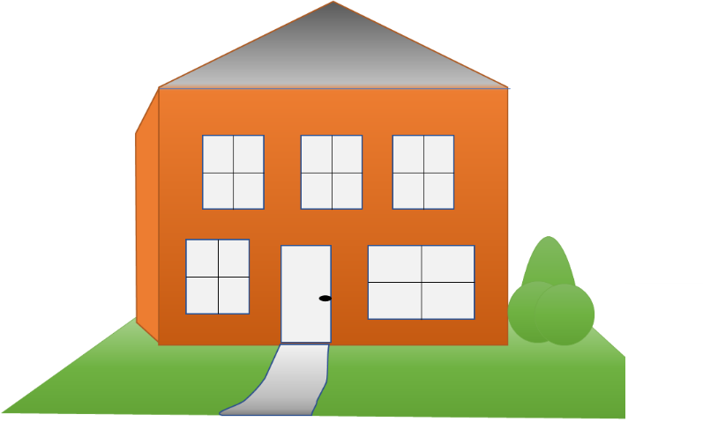
Organizing is the foundation for action
Imagine a developer who will only pay for the visible house, and not the foundation upon which it rests. Without a strong foundation, the house will not withstand the test of time.
Organizing communities is an investment in the foundation for community action. Whatever the issue, or the objective, an organized community can help engage and support action.
For funders, a community action plan is a sign of an organized community that has the capacity to deliver solutions.

Communities connect with Canadians
Do the math. 5,000 communities across Canada, each with at least 20 organizations, and each organization with the capacity to reach at least 360 people equals 36 million people. That’s the population of Canada.
Integrate this model into the community engagement strategies of senior and municipal governments, foundations, and the voluntary sector, and we have the potential to build a powerful partnership for social marketing and the delivery of solutions at the local level.
A little organizing can go a long way

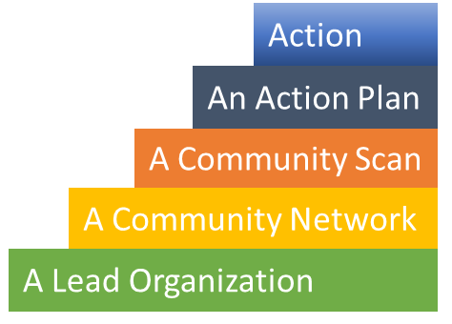
The Five Steps
The key to community organizing is to make it simple and flexible: simple enough that it is not a drain on limited resources, and flexible enough that any community can adapt the process to fit its circumstances.
Communities are already a hive of activity. The goal for organizing a community is to harness and focus that energy on common goals. Each participating organization should benefit, and their members should see individual and community benefits as well.
Community groups usually have limited resources and they depend on volunteers and grants to get their work done. Community organizing should help promote and support their work.
Organizing a community should be a simple process, one that builds on the existing knowledge and expertise within the community groups. It should be a logical flow from the desire to organize to improved action on the ground. Five simple steps.

- Identify a Lead Organization

To get the ball rolling, you need a spark. Usually, this is an organization in the community, but in reality anyone can start the process of organizing a community. In fact, leadership usually involves both an organization and a person. The organization is a host that can provide administrative support and receive funds for a community plan. The individual will be a good organizer who can work in support of the entire network and the community as a whole. A community lead can be:
- A not-for-profit or charitable organization
- An unincorporated community group
- A community leader
- A local politician
If you are looking to fund your process with a grant, then you will need to have an organization act as the host for the project and assume financial responsibility.
The lead organization will likely also be an active member in the community and will have a stake in the community action plan. Make a clear distinction between the organization’s role as host and participant. You can also appoint or hire someone to lead the community planning process on behalf of all participating groups. It is also possible to rotate lead organizations, or to have a different organization lead a separate planning process. The key is to maintain both trust and momentum.

2. Create a Community Network

A community network can be as simple as a contact list for organizations in the community that are interested in working together. For neighbourhoods, look to include:

- Residents’ associations
- Social service groups
- Business associations (Business Improvement Areas or Chamber of Commerce)
- Arts and Cultural associations
- Faith communities
- Schools and school clubs
- Libraries
- Recreation groups
If you are organizing a cultural, faith, or professional community, look to include the different organizations that serve your community across the scope of your activities.
Also include people who should be informed of your activities, and who can lend support, such as your political representatives, sponsors, and senior organizations.
Start an Excel spreadsheet and share it online with the members of your network so they can update information or add new contacts to the list:
OUR COMMUNITY NETWORK
First Name | Last Name | Title | Group | e-mail | Cell | Other Phone

Once you have a contact list you can start exchanging information:
- Set up a group e-mail list, or a Mail Chimp newsletter to share information
- Organize a networking social to get to know everyone. Most people probably already know each other, so an informal meeting is an easy way to get people talking about the benefits of collaboration and a community action plan.
- The lead organization, or organizer, can send around regular updates on events and opportunities for collaboration and funding.
If you start getting more elaborate, there are other online tools to support collaboration. Start simple, and evolve.
Most community group leaders already know each other. Creating a community network is a small step in acknowledging common interests and the potential for collaboration.

3. Compile a Community Scan

Who’s doing what? Spend a week to research and compile the major projects and activities of community groups. What are the main issues and challenges, and how are the groups addressing them?
GROUP
Name: Website:
Number of members: Number of staff: Number of volunteers:
Type:  residents  business  faith  cultural  social service  recreation  other
Description:

Contact: Title:
E-mail: Phone:
ACTIVITY (copy and paste for additional activities)
Title:
Web page:
Description:

Contact: Title:
E-mail: Phone:
Notes:

Create a document in either Word or Excel:
- MS Word – allows for flexibility in entering information. Have a separate page for each entry.
- MS Excel – provides a common format, and is easy to extract information (such as a contact list) but it can be harder to read
Use Google Docs or any other shared document platform to allow members of your network to edit and contribute information on their programs and activities. The end result will be an internal research document that can is not designed for publication, but that will help frame your community action plan.

4. Produce a Community Action Plan

Now the fun begins. By now you have a list of interested groups and individuals, and a sense of what is already happening in the community. This is where you paint your vision for the future and show your collective capacity to get there.
Keep it short and to the point. Most people will read your plan in less than five minutes, which means you need to you have less than twenty pages to convince them this plan is worth supporting.
- Our Vision and Goals
- How we can get there
- What help we need
- Statements of support and thanks
Be inclusive. Make sure every group in your network can see itself in the plan. Hold network planning meetings to scope the plan, review a draft, and to ensure that the plan reflects the community needs. You may also want to host a public workshop solicit other ideas from the community.
Include a range of ideas. Include both the simple ideas and the bold dreams; immediate actions that can be done with volunteers through to the big projects that will require significant funding and support. Your plan will need some quick successes to show progress and to build support for the big ideas.
- Raising awareness
- Research
- Community volunteers
- Consultation and Advocacy
- Physical Enhancement
- Services
Be creative. Sell your vision. If you have a budget, hire a writer and a designer.
Add in photos from the community. If there is a clear subject or subjects in the photo, then you should ask their permission to use the photo in your publication. Permission is not required for incidental subjects (i.e. people in a crowd).
Brand your plan. A common logo and tag line can be used by all the network members to create awareness and sell merchandise to raise some funds.
Publish online and in print. Your production costs should be low if you make it available online and publish a few hard copies for the network and for promotional purposes.
Promote your plan. Print posters and postcards for distribution in stores, libraries, schools, recreation centres, and (most of all) through your network’s meetings and member outreach. Host a release event for all the organizations and invite you local politicians, potential allies, and media.

5. Action on the Ground

Move quickly from planning to action. Start with the low-hanging fruit – the quick-start activities that will create awareness, give you early results, and pave the way for deeper action. Be visible.
Build momentum. Whether you seek to educate people about issues, help them take action, advocate on behalf of the community, or take on physical projects to enhance the community, your action plan should flow from simple projects to the more complex.

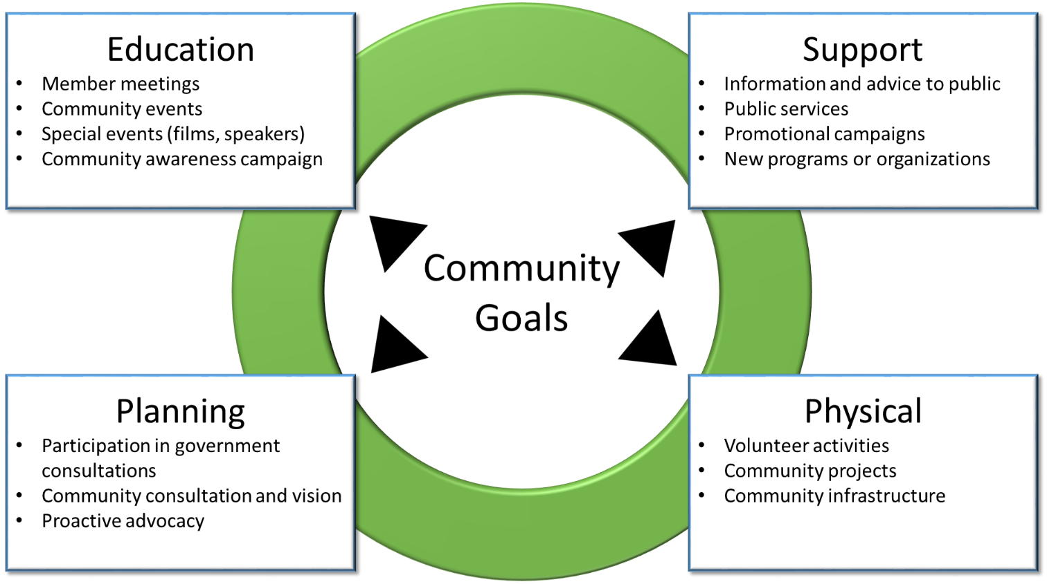

Fundraise. Work with your community foundation, or crowdsource for a community fund to support projects under the community plan. Find champions for your plan in your elected representatives, local business, and community leaders.
Celebrate successes. Hold workshops or a community feast to celebrate successes and recognize community leaders, volunteers, and supporters
Review and update the plan. A good plan can last several years. It might need minor tweaks and updates along the way until eventually groups decide to revisit the process and draft a new version.

Some Assembly Required

Simple does not necessarily mean easy.
A road still needs to be built, whether you blast through the mountain, or follow its contours. This guide lays out what is perhaps the simplest path to organizing a community, but it will still take leadership skills and work to pull it together.

One of the first challenges is learning to think like a community. We devote most of our time and energy to our jobs, organization, or company. Community groups often work together and share common purpose, however community action challenges us to take collaboration to a new level with joint projects, co-marketing, community campaigns and common fundraising. Organizing a community may require working across different languages, cultures, faiths, ideologies, and economic backgrounds to find common ground and ways to build a better future for all. It can be as challenging as it is rewarding.

One size does not fit all.
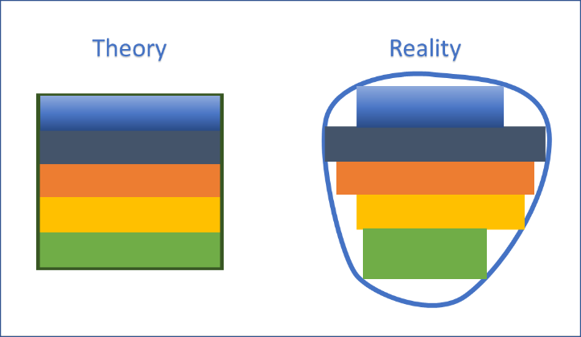
Each community is different. A community can be a neighbourhood, a provincial network, or a cultural or faith community. You will invariably have to adapt this simple process to meet the needs of your community.

You may need a strong lead organization, or it could be a volunteer group. You may have many community groups, or only a few. You may want to include lots of existing activities and priorities, or only a few relevant ones. And you may want to invest more time in engaging the community directly as opposed to working through your network members.

The focus of your community plan can be broad or narrow. You can start from the perspective of community needs, from the perspective of social, economic, or environmental priorities, or with an eye to tapping into community funding streams.

This is a really simple guide for a reason. It focuses on a few key steps that maximize your ability to achieve success, and it allows for all kinds of flexibility in adapting the process to your community.

Community Lenses
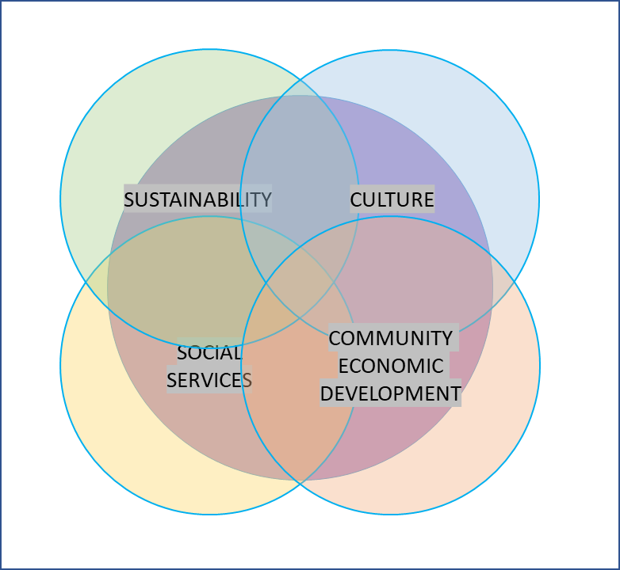
Communities, especially neighbourhood communities can be pretty complex. Not only are there diverse groups, but there will also be a diversity of issues and areas of concern. One single community action plan may not be able to cover everything.
What we have described up to now is a generic process that can be applied to any type of community and on any subject. Let’s take a quick look at the opportunities for scoping a community action plan using a community lens.
For starters, the groups in your community network likely reflect different general areas of focus, including:
- the environment and sustainability
- cultural identity
- the arts
- social services and well-being
- sports and recreation
- community economic development
Within each community, there will be specific issues and immediate challenges, such as:
- the cost of living, including rent, food, and utilities
- crime and safety
- space to play
- gridlock, transit, and safe cycling
- jobs and attracting local business
- development, including sprawl, intensification, and community planning
A community lens is a way to focus your plan – a way to tie together a number of issues within a common theme. In figuring out the lens to place on your community plan, here are three important questions to ask:
- What are the pressing needs within our community?
- What are the opportunities (such as available funding, local resources, great ideas)?
- What is the potential for synergy (actions with multiple benefits)?
Ideally, the lens you choose is just the starting point for an integrated approach to a stronger community. Through a community network and action plan, you can begin to look for the common threads and opportunities for actions and elegant solutions that have benefits across several issues and areas of focus. For example, playgrounds, organized sports, and amenities in parks increase community safety and personal health. Community gardens build community and help people lower their food costs. Community planning for a village centre can lead to more amenities, support local business, and create a walkable community. Trees, shrubs, and wildflower gardens provide habitat for wildlife, and enhance the beauty of residential streets. And so on.

The Climate Lens
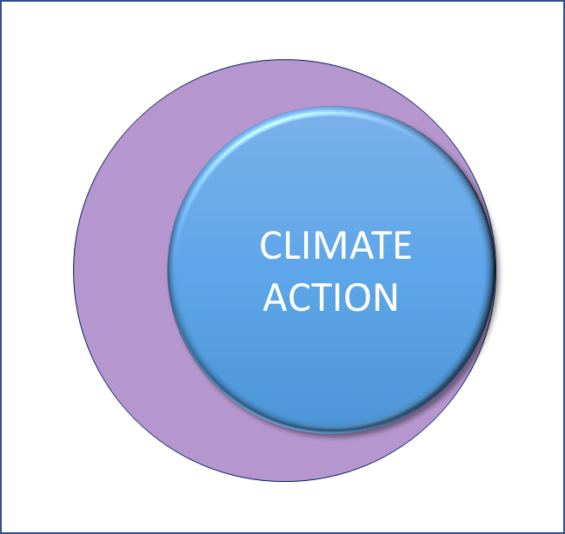
Here’s one example of a community lens: climate action.
Climate change is a major global issue, but it is also a major driving force for community action:
- Extreme weather events hit communities hard, be it through fire, floods, drought, or heavy storms, resulting in power failures or evacuations and long-term disruption.
- The economic impacts of a changing climate include increased food and fuel costs, as well as local impacts from temperature extremes.
- Individual and community action can make a significant contribution to adapting to climate change and reducing Canada’s greenhouse gas emissions.
- Community groups can play a significant role in promoting climate action through public engagement and community projects
- Compact, vibrant neighbourhood communities support a low-carbon lifestyle
- Project funding is, or will be available as carbon pricing leads to funding for climate solutions
Climate solutions have strong links to social benefits, so a community climate action plan can be tailored to meet the needs of different communities, such as urban or rural, high or low income.
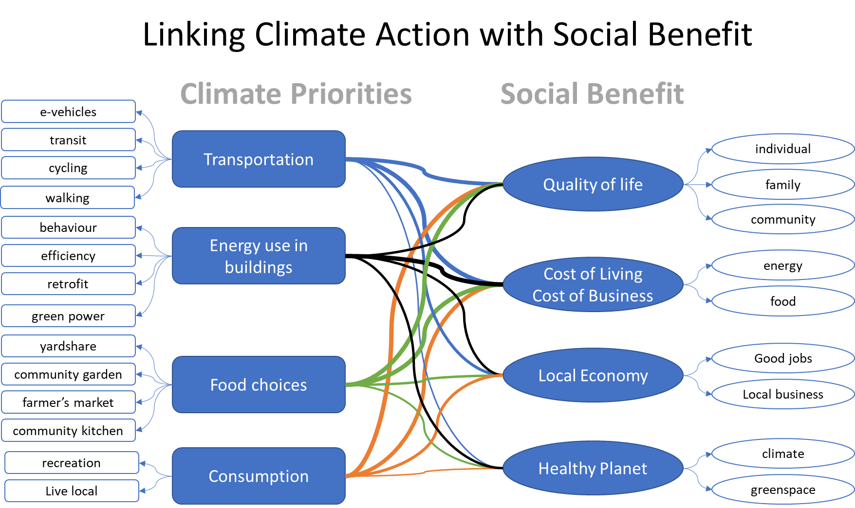

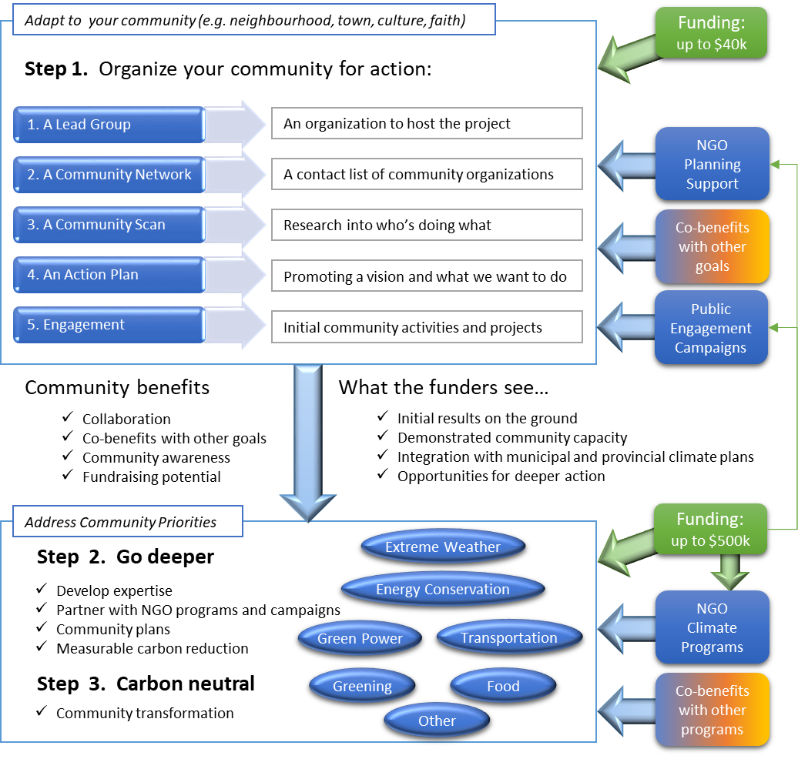
Tackling climate change may seem a daunting task, but we can see how organizing a community for climate action moves logically from community awareness and engagement to more challenging community projects

You can find more information on organizing communities for climate action at www.climateaction.ca, including 50+ Ideas for Community Engagement on Climate Action.

Batteries Not Included

The really simple approach to organizing a community can be done for nothing, or for around $40,000 – depending on how you approach it. Start with a community spark and find allies in the community to form your network. From there, you can either work on a volunteer basis or seek funding.
Item | Free | Paid
Coordinator | Volunteer position | Contract position
Meetings | Free space | Refreshments
Design | Volunteer design | Professional design
Publications | On-line | Print version
Outreach | Via network | Contract positions

Here’s a sample budget, based on a grant of $40,000:
Item | Cost | Description
Coordinator | $20,000 | Contract position
Meetings | 1,000 | Refreshments
Action Plan - Design | 2,000 | Professional design
Action Plan - Publication | 2,000 | Print version
Outreach - ambassadors | 5,000 | Small contracts
Outreach - events | 2,000 | E.g. a community fair
Outreach - material | 3,000 | Web page, print material
Overhead (approx. 15%) | 5,000 | (Approx. 15%)
TOTAL | 40,000

If you are a government or foundation looking to support community organizing as a foundation for community enhancement or action on specific issues, the best way to proceed is to establish a community planning fund with a simple application form.
Requirements: | - A lead organization (not-for-profit)  - A community network (initial members)  - Letters of support (e.g. elected representatives)
Deliverables: | - A community scan  - A community action plan  - Initial measurable results (community engagement)
To estimate the size of a community planning fund, look at providing up to $40,000 a year for one quarter of the communities in your jurisdiction. You can reduce the cost by partnering with other levels of government or funding agencies.
Your fund should dovetail with other project funding for community action on specific issues.

Good luck
This guide was written by Chris Winter for Climate Action Canada. It is made available in MS Word and PDF formats at www.climateaction.ca. All ideas and templates can be freely adapted and used by any community plan.

Additional Resources – community planning

Tamarack Institute (http://www.tamarackcommunity.ca/)
Resources on community planning and the collective impact model
Canadian Index of Well Being (https://uwaterloo.ca/canadian-index-wellbeing/)
A periodic report tracking key statistics on Canadian well-being. The report is used by community foundations across Canada as part of their Vital Signs reports.
Transition Towns (https://transitionnetwork.org/)
A movement of communities coming together to reimagine and rebuild our world.

Additional Resources – community climate action
Climate Hubs (http://www.climatehub.ca/)
An initiative of Climate Reality Canada to support climate hubs in communities across Canada
Green Communities Canada (http://greencommunitiescanada.org/)
A national association of community organizations that help people go green – in their homes and gardens, on the road, at work, and in the community.

